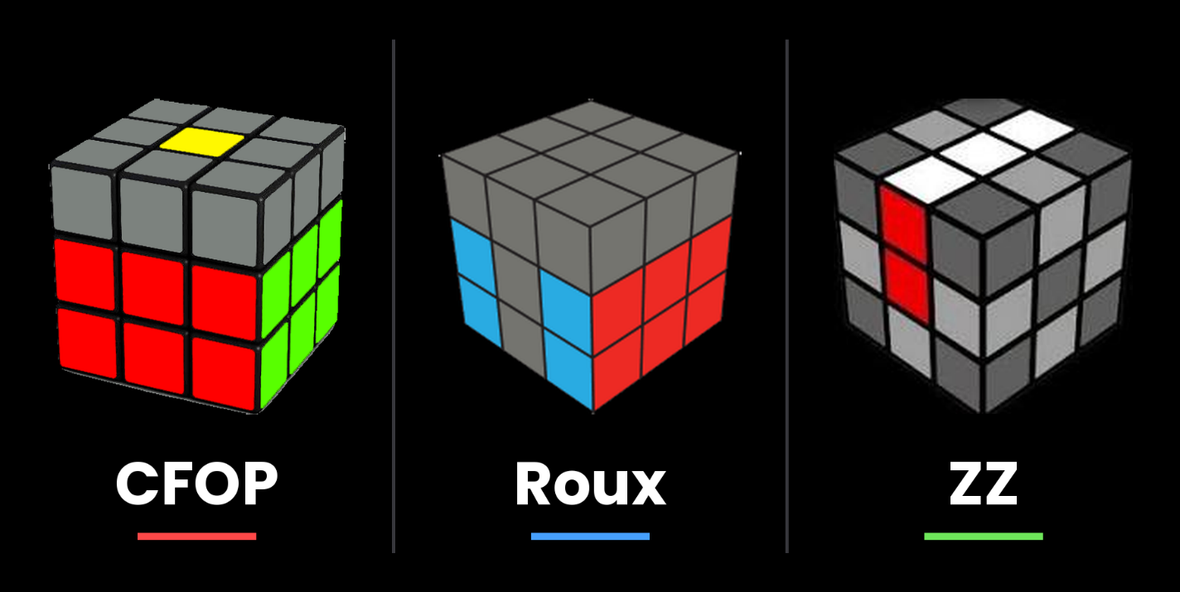
CFOP vs Roux vs ZZ: Which Cube-Solving Method Is Right For You?

In the speedcubing world, there are many different methods that professionals use: CFOP, Roux, and ZZ. Each one offers different advantages and edges over each other, but knowing which one to learn to use on your own could be really difficult. This blog aims to help you discover which one will work best for you. Let’s break down how each method works, what makes it unique, and who it’s best suited for.
CFOP

